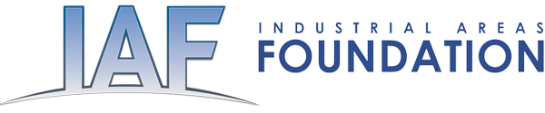

September 12, 2016

Dear

We are faith and community leaders representing local non-partisan community organizations in twenty-two states and the District of Columbia. These local organizations are a partnership between local community institutions and the Industrial Areas Foundation, the nations oldest and largest network of organizers.

For over twenty-two years our network has been engaged in developing local citizens organizations in Louisiana. Today our sister organizations represent over 250 institutions spread across the state with over 250,000 members. Together Baton Rouge, Northern and Central Louisiana Interfaith and our state network, Together Louisiana have been assisting in the immediate response but are also working with Gov. John Bel Edwards and his staff and our congressional delegation to deal with the recovery, immediate and long-term.

We need your immediate assistance in seeking support for a bi-partisan request for a $2 billion dollar appropriation of Community Development block grant funds for Housing Repair, Rental Assistance, Small Business Assistance and Emergency Infrastructure Repair. Gov. Jon Bel Edwards made this request to President Obama on Friday. This request has the support of the entire Louisiana Delegation.

Brief Detail Inserted

Thank your for your consideration and support. Our leaders will be in touch with your staff immediately to follow-up on this request.

On behalf of the Industrial Areas Foundation Network of Organizations,

