In the Southern Hemisphere we are sliding into one of the hottest summers on record. We take a moment to take stock of some of our wins as the democratic heat rises in Sydney!

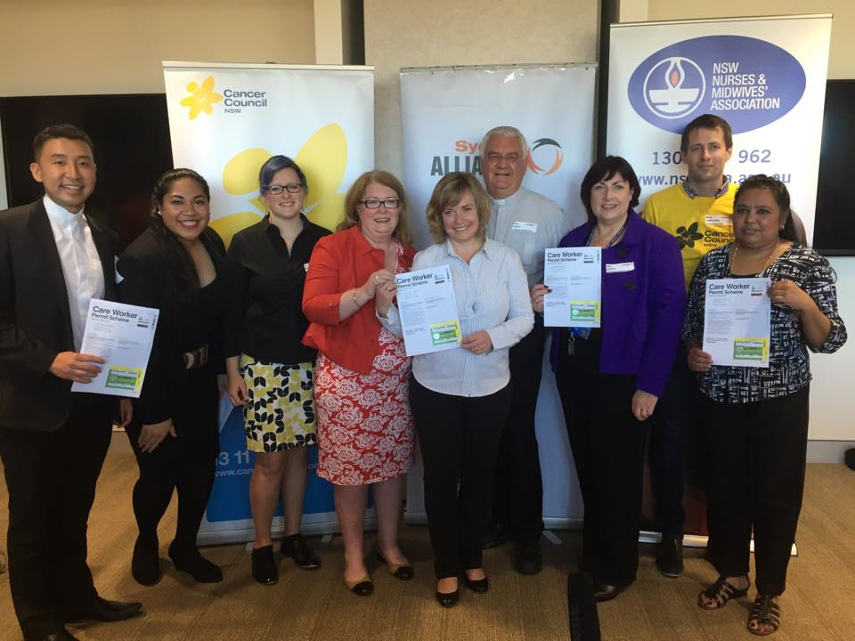

Sydney’s inner city nurses, cancer council advocates, home care workers, patients and their loved ones celebrate new parking stickers allowing carers to provide care visits to patients without being booked by parking rangers!

This was a 20 year campaign run by the New South Wales Nurses & Midwives’ Association, completed in 18 months thanks to relational power and community organising! Solid recognition from local health care bosses and local gov. officials, see the video here.

***
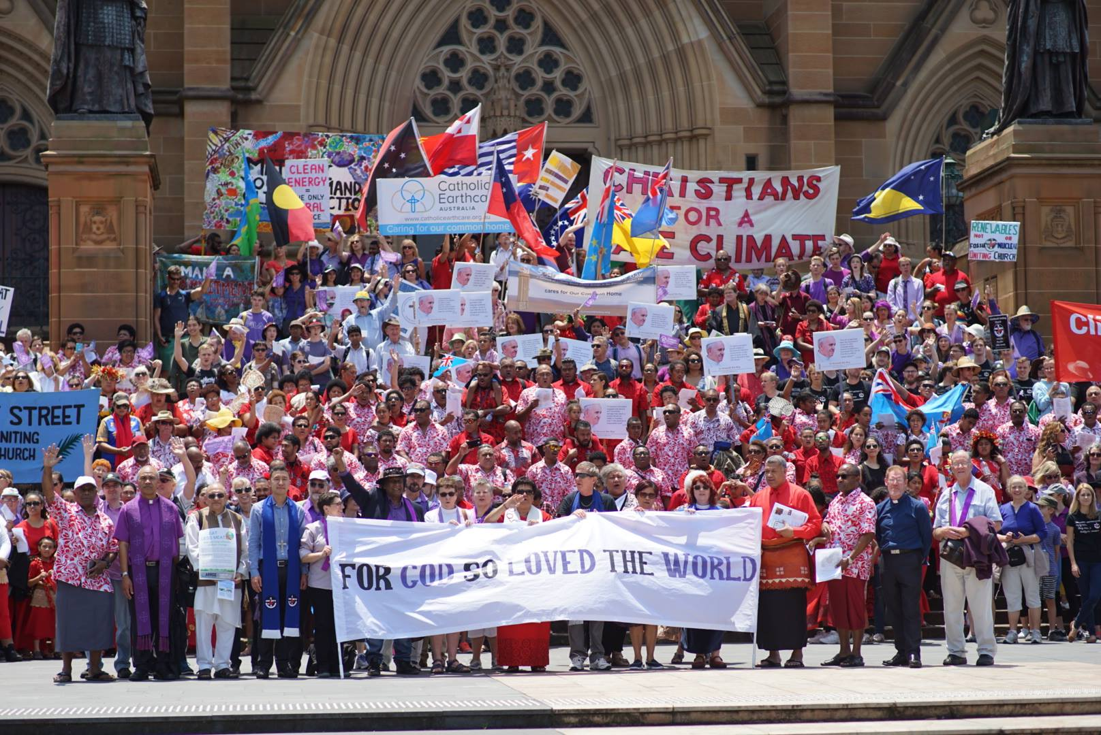

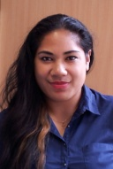
Liuanga Palu, Pacific Communities Organiser with Sydney Alliance is as cynical as the rest of us on the effectiveness of rallies – “but this one had a difference. We ran an internal action on our partner organisations. It was also an action on the big enviro ngos, they will need to do things differently if they want our communities engaged. We have to meet on common, relational ground”.

Over the last few years conservative Australian politicians joined Canada’s Steven Harper and US Republicans as the recalcitrant villains at world climate change conferences. Using the urgency of the Paris agreement on Climate Change Sydney Alliance partners - Unions, environment groups, Muslim groups, churches, Jewish and ethnic communities used a six month community organising strategy to train hundreds of leaders in relational and house meetings.

Alfreda Vakarewakobau, a mother and member of Fijian Parish Church Canterbury said “We translated IAF house meetings into ‘Intentional Talanoas’ around the Kava bowl (traditional Fijian practice of drinking and conversing). Even though our villages are being relocated away from the beaches, and we are in existential crises back in the islands, the 80’000 strong Pacific Islander Diaspora in Sydney has never been politically active on climate change. Through community organising that changed at the People’s Climate March. It has opened up new conversations about how our communities relate to the whole”.

Liuanga said “We are very visual people, we learn best through visual presentation –the march was a powerful representation about how visually, Sydney should look like and this was prompted a new momentum and a new calling to be politically active”.

Videos: Organising & The Climate March (5 min) & Pacific Focus (1.5 min)

***

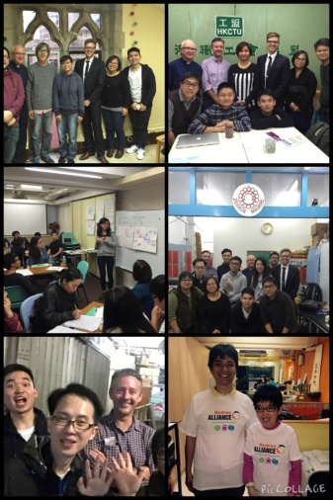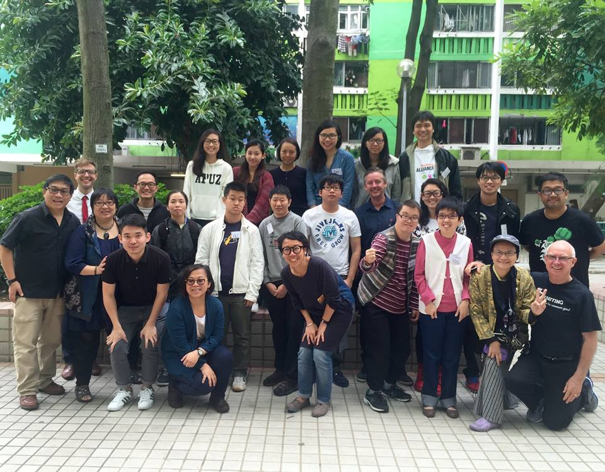

Thanks to the Hao Ran Foundation, Sydney Alliance and newly emerging Hong Kong Citizens are exploring together how to translate IAF practices to diverse cultures on the Eastern edge of the Pacific.
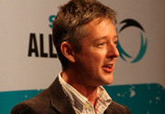
Associate Professor Kurt Iveson, Sydney Alliance leader from the National Tertiary Education Union said “First, the trip provided us with a powerful reminder not to take our own Alliance in Sydney for granted. Hong Kong civil society has fractured following the Umbrella Movement and occupation. There is strong polarisation between those perceived to be ‘pro-Government’ and ‘pan-Democrat’.
There is also a growing rift between existing civil society institutions like unions and neighbourhood associations, and the young Umbrella activists who have a deep mistrust of those institutions as vehicles for achieving change. This latter division is especially problematic. For those we talked to across this divide, the story of the Sydney Alliance clearly conveyed great hope – and our training actually brought together a very diverse group of people and shared some skills for working through divisions and building effective alliances”.
“Second, in a meeting with so-called ‘self-help’ or ‘self-advocacy’ groups including ‘Chosen Power’, we were taught a lesson about the importance of building an inclusive Alliance. The night before the training started, a group of people with intellectual and physical differences told us the story of how they are building organisations to advocate on their own behalf and care for one another. Members of one of these groups – Chosen Power – participated without their support worker, who sat in another room while the meeting took place. Their moto ‘nothing about us without us’ is about as clear a statement of our ‘iron rule’ as you can get.
When they asked us about the existence of such groups in Sydney, and about whether they were participating in our Alliance, we had to confess that no, such groups were not involved. In response, they taught us about techniques they were using to make written and verbal communication more inclusive of people with physical and intellectual differences – techniques that are already being put to work very effectively by Hong Kong Citizens in their communications.
In short, this group ran a very effective agitation and action on us – and we committed to working to make our Alliance more inclusive of people with intellectual and physical differences when we returned”.
A delegation of 9-12 Hong Kong Citizens leaders will visit Sydney Alliance in 2016. Sydney Alliance partners will be using the tour as an opportunity to get better organised the Sydney Chinese community (about 350’000 strong).
****
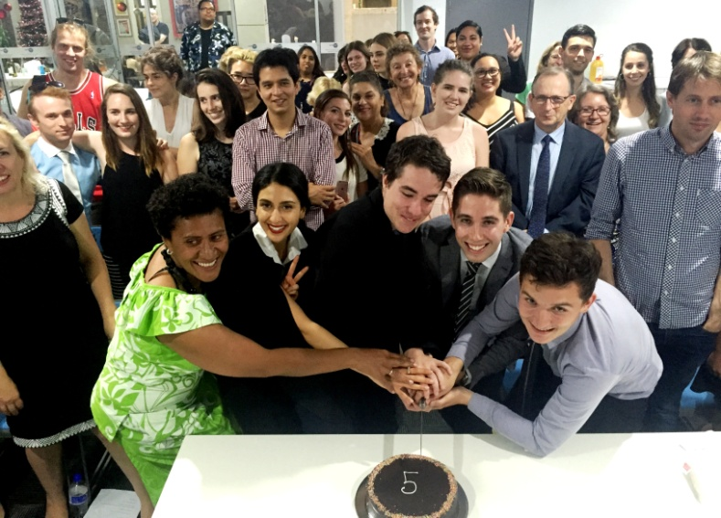
The Sydney Alliance also celebrated 5 years of internship program with a graduation of 5 more interns to join an active alumni group of 88. The five graduates match the alliance and the city in their diversity – a Fijian, Iranian Muslim, Jewish, gay and an environmentalist.

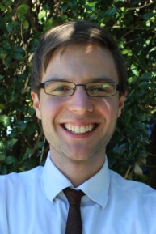
David Barrow, Lead Organiser said “Ritual – it’s something that sometimes young people feel is old hat. But a bit of ritual done well, gives us meaning – and helps us mark the seasons of our life. Today we are marking the change of seasons – from private citizen, to public person; from conventional social worker, to dynamic societal change maker; from unreflective activist, to considerate leader.

The graduation ceremony honours those that love and guide these folks- their family and loved ones. Because we know it takes a village to make these wonderful people before us.
We are also celebrating 5 years of the internship program. We have had 88 graduates through the program, and now they are across the world, NSW and Sydney doing amazing things; working in trade unions, in churches, in the UN refugee program, in the Red Cross, in Cancer and disability organising, and social urban planning, in social justice law firms and women’s refuges.
We set up this program because many young people haven’t had the experience of being part of an organisation. They haven’t built up the thick skin needed for a rich deliberative democracy, haven’t built up the resilience to know how to contribute and sacrifice to a voluntary association like their parents or grandparents might have in order to gain the great gifts that living a collective life gives us.

Our dream at the Alliance is that in ten years time or twenty years time – when these folks run the Sydney Alliance partner organisations- they will already have the relationships across social business and union, catholic, protestant, Jewish, Muslim, Buddhist and atheist communities and a reflective, collectively held culture of relational, broad based organising.

